https://arduino.stackexchange.com/questions/78552/wiring-up-an-esp-01-to-nano?answertab=votes#tab-top
https://www.electronicslovers.com/2017/11/learn-how-to-setup-wifi-module-esp8266.html
https://www.youtube.com/watch?v=YKn2ZXYb_EI
arduino nano esp8266 esp 01 wifi
use buck converter (LM2596) for 3.3v
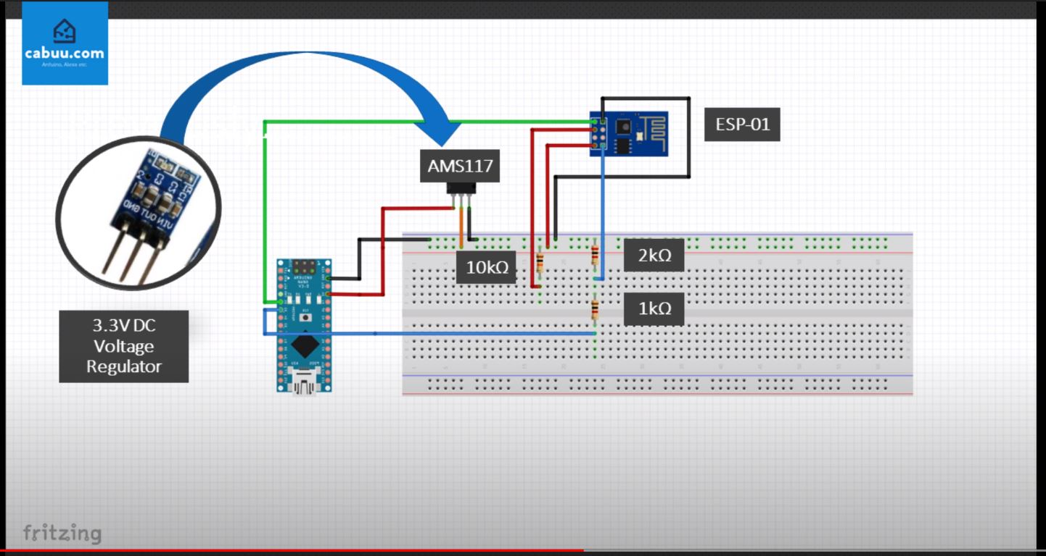nanoesp01cablage.jpg
- There is a bug in the code:
- SoftwareSerial softSerial(3, 2); RX, TX * should be * SoftwareSerial softSerial(2, 3); RX, TX
- Also the suggested baud rate of 9600 doesnt seem to work, adjust to 115200 and go from there. Once you get a receiving signal, run the following to adjust the 01's baud to 9600:
- AT+UART_DEF=9600,8,1,0,0
- After this, reflash your nano with serial bauds set to 9600 and you should be able to send AT commands over your Nano to the ESP-01 via 9600 baud
#include <SoftwareSerial.h>
SoftwareSerial softSerial(2, 3); // RX, TX
void setup()
{
uint32_t baud = 9600;
Serial.begin(baud);
softSerial.begin(baud);
Serial.print("SETUP!! @");
Serial.println(baud);
}
void loop()
{
while(softSerial.available() > 0)
{
char a = softSerial.read();
if(a =='\0')
continue;
if(a != 'r' && a != 'n' && (a < 32))
continue;
Serial.print(a);
}
while(Serial.available() > 0)
{
char a = Serial.read();
Serial.write(a);
softSerial.write(a);
}
}
- AT – Will give OK on the serial monitor, if Not just unplug vcc Pin of ESP8266 Module for a moment and reconnect again.
- Send AT+RST – Command to Restart module / Optional Command
- Send AT+GMR – To get the firmware version
- Send AT+CWMODE? – Set Module to a Dual Mode Sucha as Standalone + Access Point mode.
- Send AT+CWLAP – Command to Search Nearby Wifi Access Point. Find your Wifi Name in the Search Result.
- Send AT+CWJAP=”Your Wifi Name”,”Your Wifi Password” – Command to Connect to WIFI.
- Send AT+CIFSR – Command to Check Allocated Ip given by your Wifi to your ESP8266 Module/Optional Command.

