https://www.calculator.net/body-fat-calculator.html?ctype=metric&csex=m&cage=42&cweightlbs=152&cheightfeet=5&cheightinch=10.5&cneckfeet=1&cneckinch=7.5&cwaistfeet=3&cwaistinch=1.5&chipfeet=2&chipinch=10.5&cweightkgs=120&cheightmeter=194&cneckmeter=37&cwaistmeter=126&chipmeter=113&x=20&y=11

10/09/2019
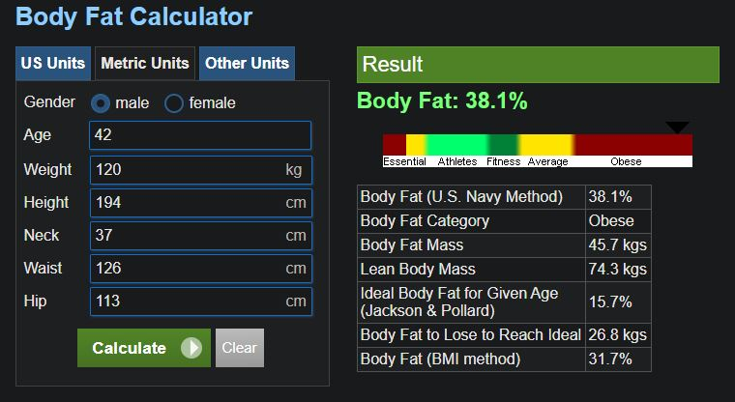body_fat_calculator_2019-09-10.jpg

10/10/2019
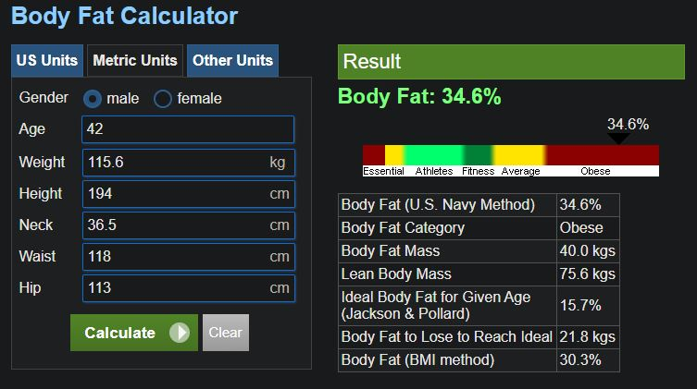body_fat_calculator_2019-10-10.jpg

10/11/2019


