Boitier
Sony Alpha 58
Sony Alpha 58
caracteristique sony slt-a58
test miss numerique slt-a58

Objectif

Sony - AF DT 18-55 F3.5-5.6 SAM II
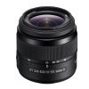Sony-AF-DT-18-55mm-F3.5-5.6-SAM-II
Sony - AF DT 18-55 F3.5-5.6 SAM II
Product code: SAL1855-2
mount (format): A (APS-C)
status: Current
year: 2013

Minolta - AF 35-70 F4
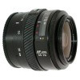Minolta-AF-35-70mm-F4
Minolta - AF 35-70 F4
Product code: 2551-100
mount (format): A (Full frame)
status: Discontinued
year: 1985

Sony - AF DT 50 F1.8 SAM
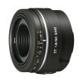Sony-AF-DT-50mm-F1.8-SAM
Sony - AF DT 50 F1.8 SAM
Product code: SAL50F18
mount (format): A (APS-C)
status: Current
year: 2009

Minolta - AF 70-210 F4 (beercan)
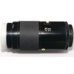Minolta-AF-70-210mm-F4-(beercan)
Minolta - AF 70-210 F4 (beercan)
Product code: 2555-110
mount (format): A (Full frame)
status: Discontinued
year: 1985

Minolta - AF 75-300 F4.5-5.6 D
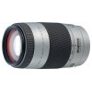Minolta-AF-75-300mm-F4.5-5.6-D
Minolta - AF 75-300 F4.5-5.6 D
Product code: 2684-910, 2684-960
mount (format): A (Full frame)
status: Discontinued
year: 2001
fov=

Field of view
FOV = 2 * Atan( Diag / (2 * focale) )
Pour le alpha 58 , le capteur fait 23,2 x 15,4 mm (format APS-C)
soit une Diag de 27,85 (crop: 1.55x)
Focal (mm) | 10 | 18 | 35 | 40 | 50 | 55 | 70 | 75 | 210 | 300
Diag FOV (°) 1.55x | 108.62 | 75.42 | 43.38 | 38.38 | 31.12 | 28.40 | 22.48 | 21.02 | 7.58 | 5.3
Diag FOV (°) 1x | 130.4 | 100.5 | 63.4 | 56.63 | 46.8 | 42.9 | 34.3 | 32.2 | 11.8 | 8.2
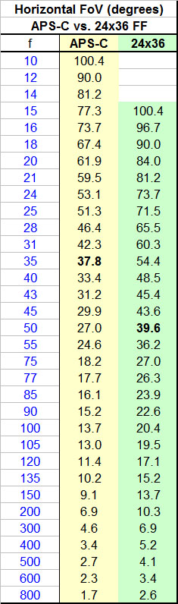www.pentaxforums.com_forums_members_77-ole_albums_596-illustrations_picture99095.jpg

